**Task 20: Pods and Services in Kubernetes Deployment**

1. **Launch an instance:**

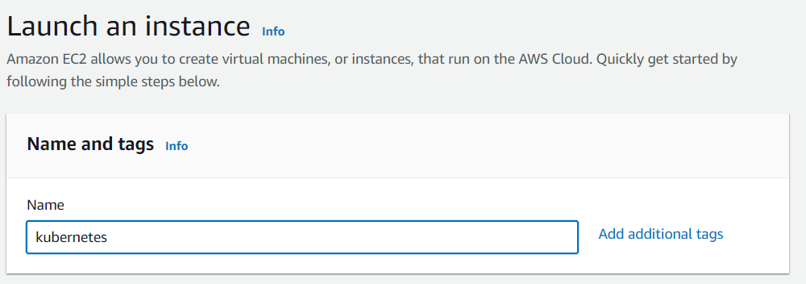

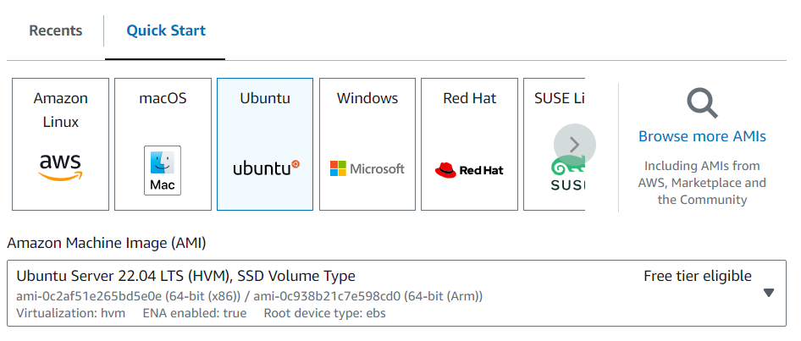

1. **Install awscli:**

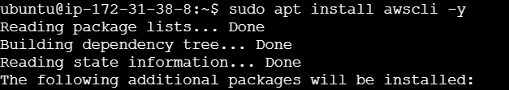

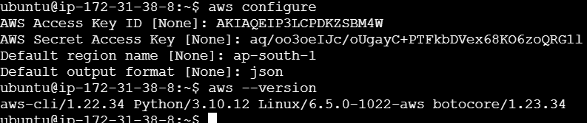

1. **Install kubectl:**



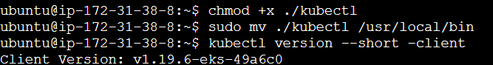

1. **Install eksctl:**



1. **Create eks cluster:**

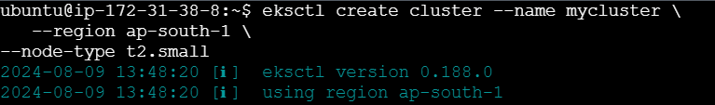

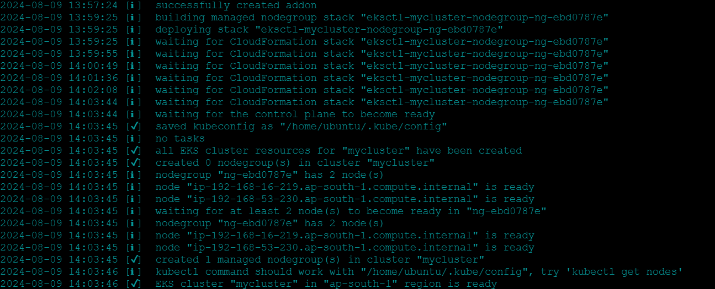



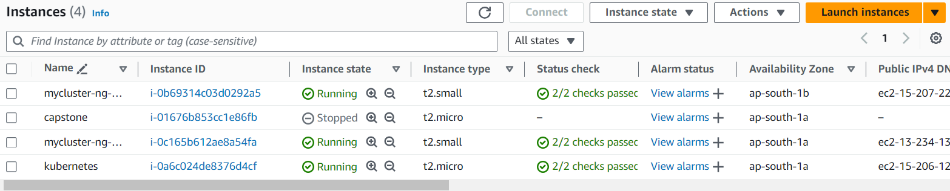

1. **Deployment file:**

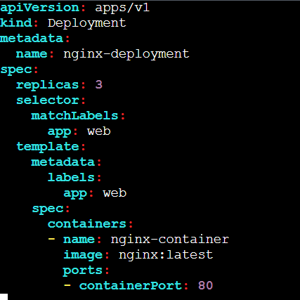

**Execute deployment.yaml file:**

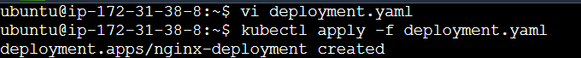

1. **service file:**

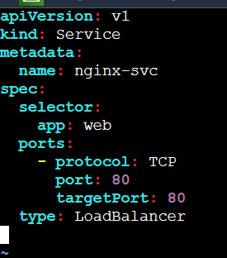

**Execute service.yaml file:**

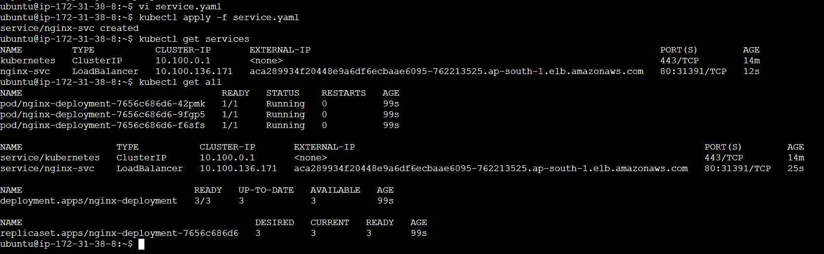

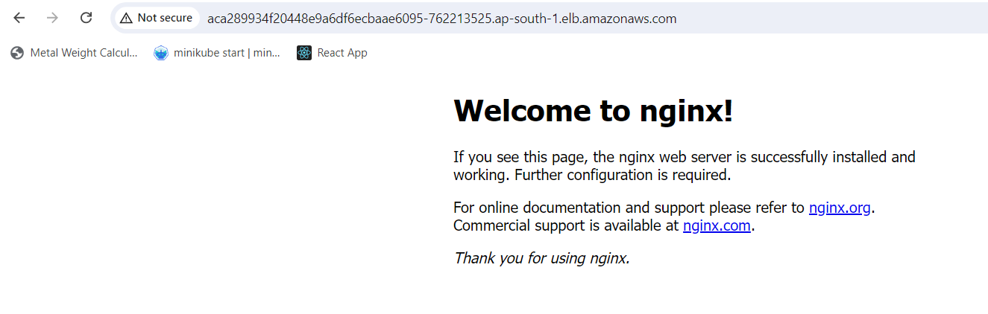

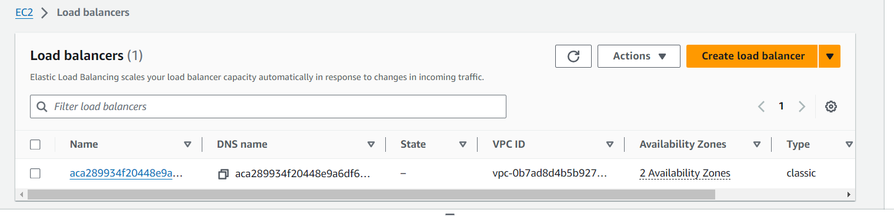

1. **pod file:**

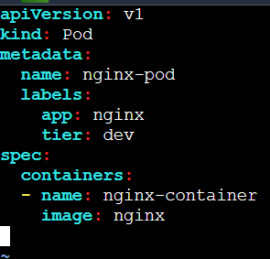

**Execute pod.yaml file:**

